# EPPS 6356: Data Visualization – Assignment 2

Using Paul Murrell’s R Examples (selected).

## 1) Basics: pressure plot

I plotted the built-in dataset `pressure` and annotated the chart. Note:I changeg the plotting symbol using the `pch` argument (e.g., 1 for hollow circle, 16/19 for solid circle, 17 for triangle).

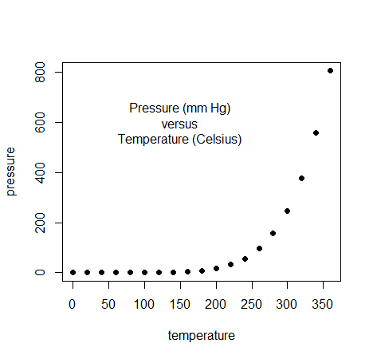

## 2) Standard high-level plots (3×2 panel)

The 3×2 layout demonstrates scatter with incremental low-level additions, histogram with density overlay, stacked bar plot with labels, side-by-side boxplots (ToothGrowth), a 3D perspective surface, and a pie chart.

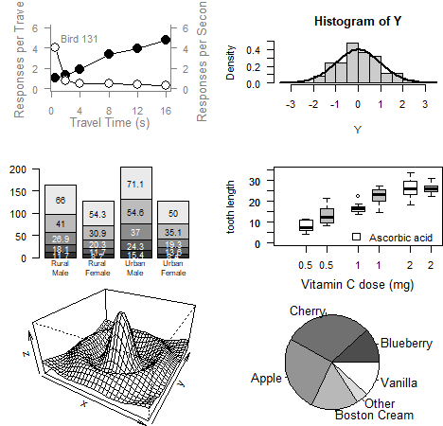

## 3) Inline Q&A

• What does the first number in `axis(1, at = ...)` stand for? Answer: It is the `side` argument — 1 = bottom, 2 = left, 3 = top, 4 = right.

• Can you change `pch`? Answer: Yes. `pch` sets the plotting character (symbol); try values like 1, 16, 17, 19, etc.

• Try different `cex` values for point size. Example: `points(x, y1, pch=16, cex=3)` enlarges the markers.

## 4) How images were generated & exported

Plots were produced in base R following Murrell’s examples. Use `png('filename.png', width=..., height=..., res=...)` before the plotting code and `dev.off()` after to export individual figures for website/blog.